**Elevate Labs Internship**

**Task -3**

**1..Create database elevatelabs**

**2..(To use that particular Database) use elevatelabs**

**3..select * from ecommerce**

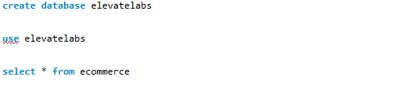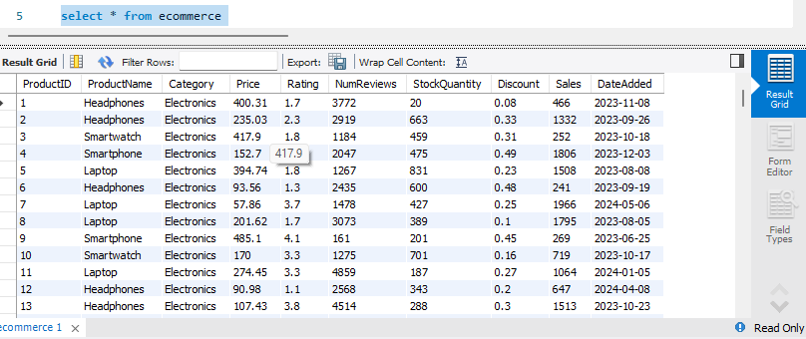

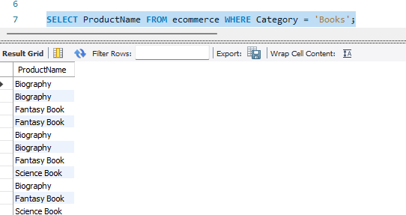

Using Where Clause :-

SELECT ProductName FROM ecommerce WHERE Category = 'Books';

**Order By Clause**

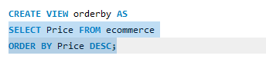

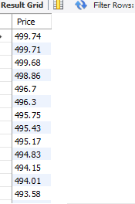

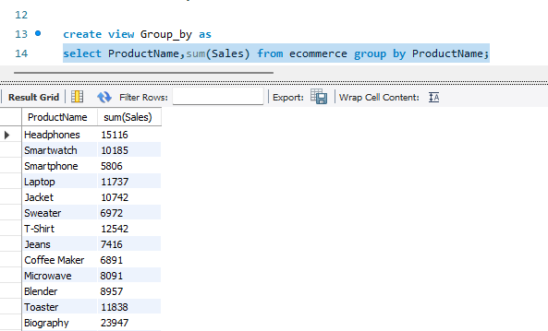

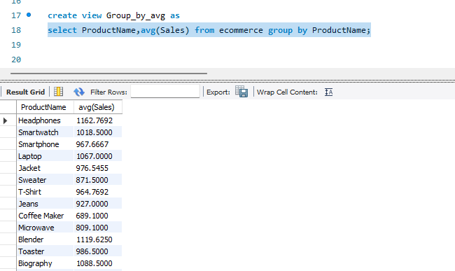

**Using Group by clause using aggregate function min,max,avg,sum etc…** 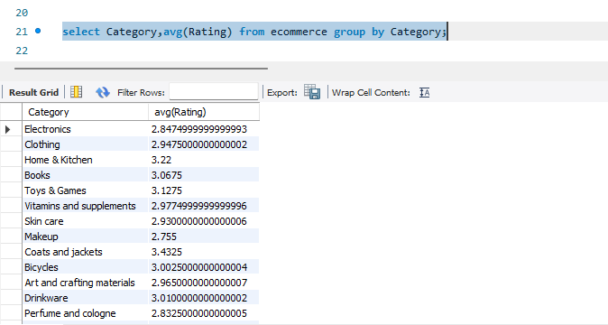

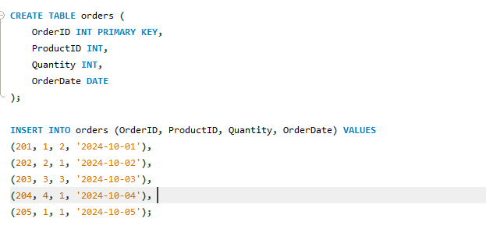

**Joins command**

* **Creating a new Table using same database because I have to use join function by creating it.**
* **There are basically three types of Joins like Inner joins,left join and last but not lest right example..**
* 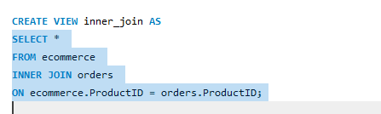

Using inner join –This basically takes all those values which are related to both the table

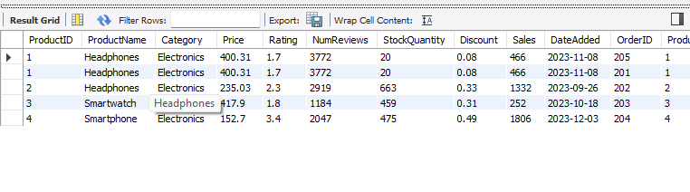

**Left Join**

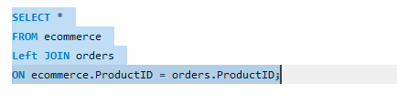

**Left Join Output**

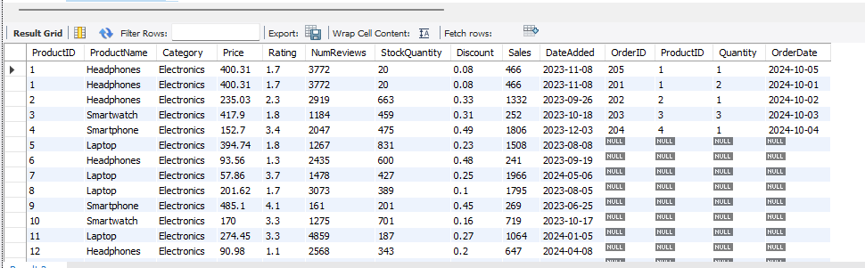

**Right Join**

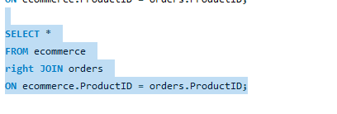

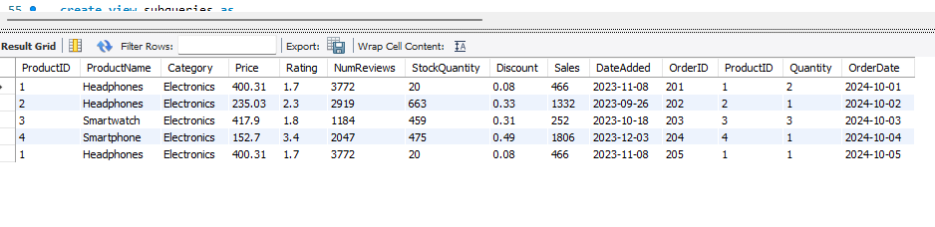

**Subqueries**

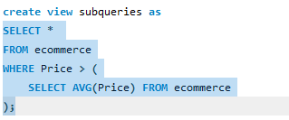

**Output**

